LETTERKENNY INSTITUTE OF TECHNOLOGY

ASSIGNMENT COVER SHEET

Lecturer’s Name: James Connolly

Assessment Title: Prediction

Work to be submitted to: James Connolly

Date for submission of work: 29-08-2018

Place and time for submitting work: 3:00 pm

To be completed by the Student

Student’s Name: PRATEEK PARASHER

Class: Msc in Big Data

Subject/Module: Data Science

Word Count (where applicable):

I confirm that the work submitted has been produced solely through my own efforts.

Student’s signature: PRATEEK PARASHER Date: 29/8/2018

|  |
| --- |
| **Notes**  **Penalties:** The total marks available for an assessment is reduced by 15% for work submitted up to one week late. The total marks available are reduced by 30% for work up to two weeks late. Assessment work received more than two weeks late will receive a mark of zero. [Incidents of alleged plagiarism and cheating are dealt with in accordance with the Institute’s Assessment Regulations.]  **Plagiarism:** Presenting the ideas etc. of someone else without proper acknowledgement (see section L1 paragraph 8).  **Cheating:** The use of unauthorised material in a test, exam etc., unauthorised access to test matter, unauthorised collusion, dishonest behaviour in respect of assessments, and deliberate plagiarism (see section L1 paragraph 8).  **Continuous Assessment:** For students repeating an examination, marks awarded for continuous assessment, shall normally be carried forward from the original examination to the repeat examination. |

**Abstract**

Working with data and playing with that always interesting and I always try to find more out of the data in this project initially my aim was finding correlation between two dataset & other hidden pattern through visualization and investing deeper into data in this project I worked on environmental I always want to know how much pollution contribute for I found one dataset initially which was not in a condition to do any testing or investigation so I clean the data pre-process that than used hypothesis testing and then the prediction which is described in a documentation.

**Data Pre-processing: –**

During this pre-processing Labs which help a lot for my actual dataset in my lab practical 1 I created data frame and examine total missing values after that removed those missing value in practical 1 lab I used diabetes dataset later in lab practical 2 I used cleaning postdata and I replaced all the missing value with suitable title and categorized the factor. After all these pre-processing it’s time for use hypotheses analysis for my dataset

**Web Scraping: -** Twitter is a great source for sentiment data and social media mining furthermore it is quite easy to get significant amounts of data to be able to scrape data from Twitter. Last year we all experienced the different climate conditions and multiple climate warning announced by govt. this lab I scrapped the data from twitter regarding climate warning like heatwaves warning, snow warning etc. after that I visualize the word cloud of scraped data from twitter.

**Data Analysis** The null hypothesis and alternate hypothesis are defined as-

H0 = The road accident is not related to the red weather warnings

H1 = The road accident is related to the red weather warnings

This data analysis task examines the relationship between in red weather warnings & road accidents of Ireland. . I applied power test, t-test , correlation test. Correlation test is used to find the sample size to perform the power analysis with effect size of 0.5 with 80% certainty and no more than a 5% chance of inaccuracy. Then the sample of 29 records is used to do the power analysis. p-value is significantly high from 0.05. Therefore, this proves that the null hypothesis is true. It was seen that 29 data values are needed in each sample to have 80% of chance to reject the null hypothesis by determining the small p-value, which could reject the null hypothesis The road accident is not related to the red weather warnings.

**Predictive Modelling** As, the null hypothesis in the above step was rejected therefore, road accident is not related to the red weather warnings. Further, carrying the research now, the relation between the accidents and red warning months in Ireland was found. To proceed, correlation between the accidents and red warning months in Ireland was calculated which came out to be -0.2468042, which is a not a strong negative correlation, also the scatter graph was plotted To, proceed and get a understanding of predictive modelling the linear model was chosen to find the small correlation that still exists

**Results**

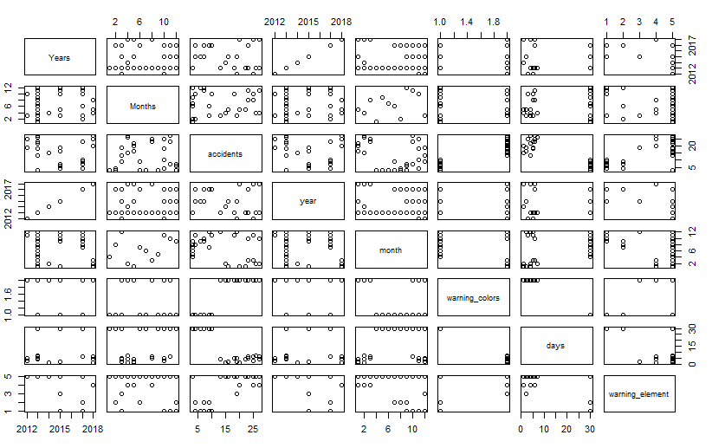

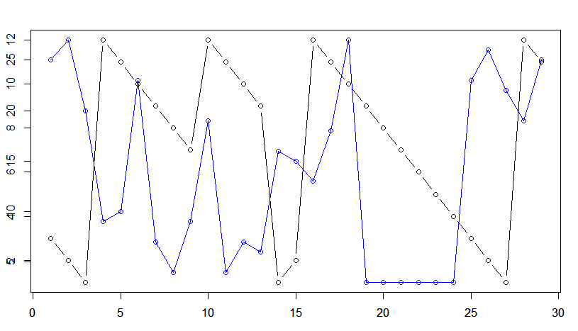

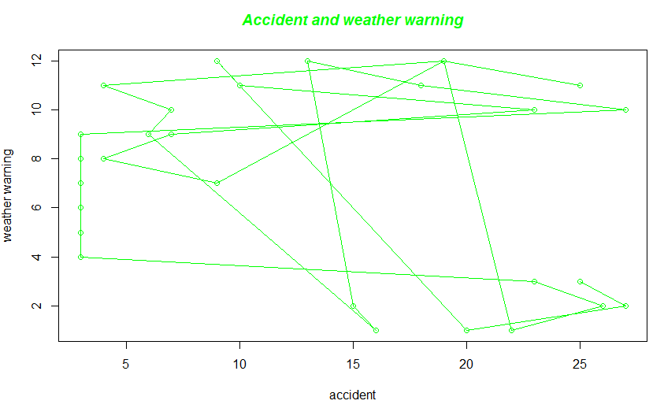

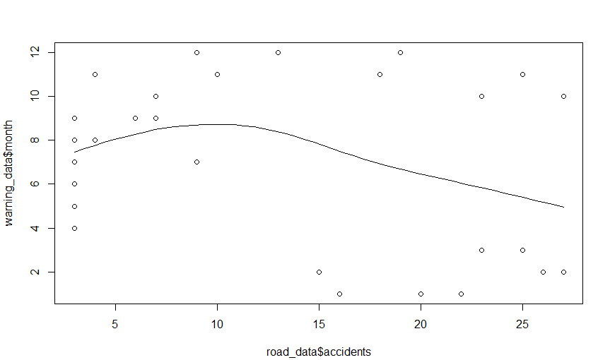

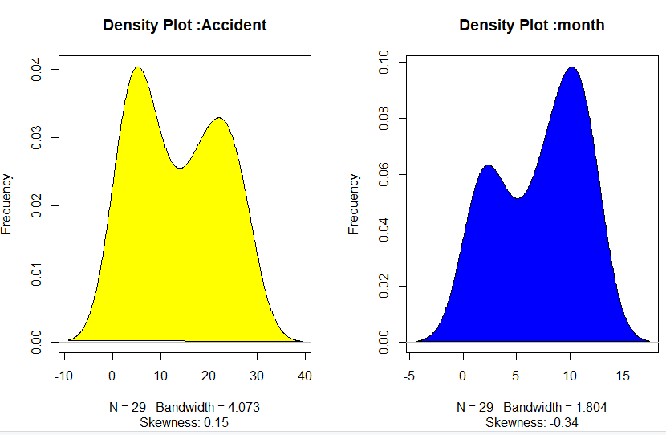

cor(road_data$accidents, warning_data$month)

[1] -0.2468042

> AIC(linearMod)

[1] 212.0835

> AIC(polynomialMod)

[1] 202.5569

> BIC(linearMod)

[1] 216.1854

> BIC(polynomialMod)

[1] 208.0261

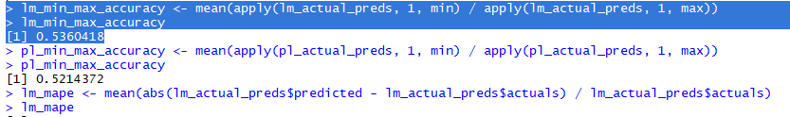

**Linear and polynomial accuracy**

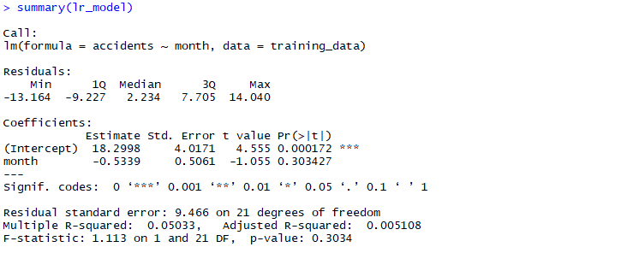

**Summary Linear**

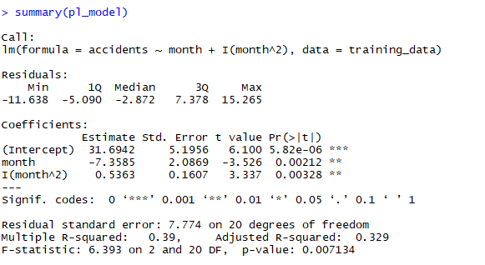

**Conclusion**

The assumption that the red warning weather data depends on road accidents in same months is failed with linear regression the p-value in linear regression is 0.303 and ideally should less that 0.05 adjusted r-squared which is inversely proportion with p value we got 0.005 which is very low ideally one should be 0.70 but on other hand with polynomial regression it seems that p value which is 0.007 which too low. all the parameter not supporting the relationship and any correlation but 2 degree polynomial model are better than linear model In future work we can try with increasing the degree of polynomial chances we might get better results